**INTI International College Penang School of Engineering and Technology**

**3+0 Bachelor of Science (Hons) in Computer Science, in collaboration with Coventry University, UK**

**3+0 Bachelor of Science (Hons) in Computing, in collaboration with Coventry University, UK**

**Coursework cover sheet**

**Section A - To be completed by the student**

|  |  |
| --- | --- |
| Full Name: **KEVIN GOH WING CHIEN** | |
| CU Student ID Number: | |
| Semester: **YEAR 1 SEMESTER 1** | |
| Session:  **August 2022** | |
| Lecturer:  **Nadhrah Abdul Hadi (nadhrah.abdulhadi@newinti.edu.my)** | |
| Module Code and Title:  **4067CEM Software Design** | |
| Assignment No. / Title:  **Continuous Assessment** | % of Module Mark:  **50** |
| Hand out Date:  **6th September 2022** | Due Date:  **Task 1: 30 September 2022, by 11.59pm.**  **Task 2: 18 November 2022, by 11.59pm**  **Task 3: 4 November 2022, by 11.59pm.**  **Task 4: 4 November 2022, by 11.59pm.**  **Task 5: 4 November 2022, by 11.59pm.** |
| Penalties: No late work will be accepted. If you are unable to submit coursework on time due to extenuating circumstances, you may be eligible for an extension. Please consult the lecturer. | |
| Declaration: I/we the undersigned confirm that I/we have read and agree to abide by the University regulations on plagiarism and cheating and Faculty coursework policies and procedures. I/we confirm that this piece of work is my/our own. I/we consent to appropriate storage of our work for plagiarism checking.  Signature(s): _______***KEVIN***______________ | |

**College Buddy System**

**Description:** The College Buddy System is a system that enables INTI students to make friends with their fellow schoolmates. This system shall accompany them throughout their college life and will be a tool for them to have a fun and interesting learning experience.

**Vision:** The College Buddy System’s vision is to become the foundation for INTI students to achieve great things. As the saying goes “Great things are never accomplished alone”, the system aims to accomplish this vision by connecting students with one another as much as possible.

**Targeted user:** INTI students and lecturers

Question 1:

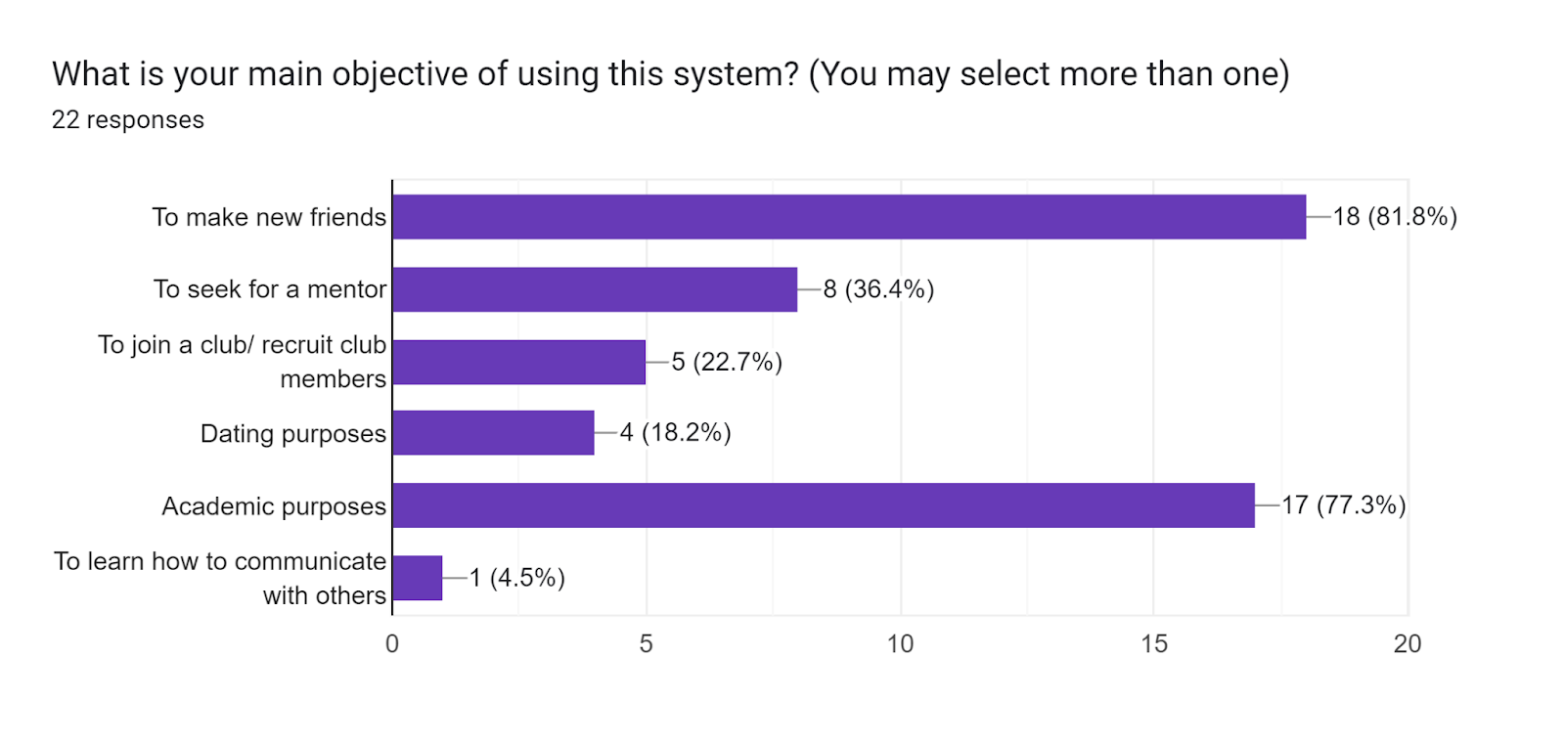

**Analysis**: A majority of the students have chosen making new friends as their primary objective of using this system. This is followed by using it for academic purposes and seeking for a mentor. The polls have also shown that romantic and club activities purposes takes a lower precedence for these students. It can be concluded that the students view this system mainly as a tool to connect with their peers and also using it mainly for academic purposes.

Question 2:

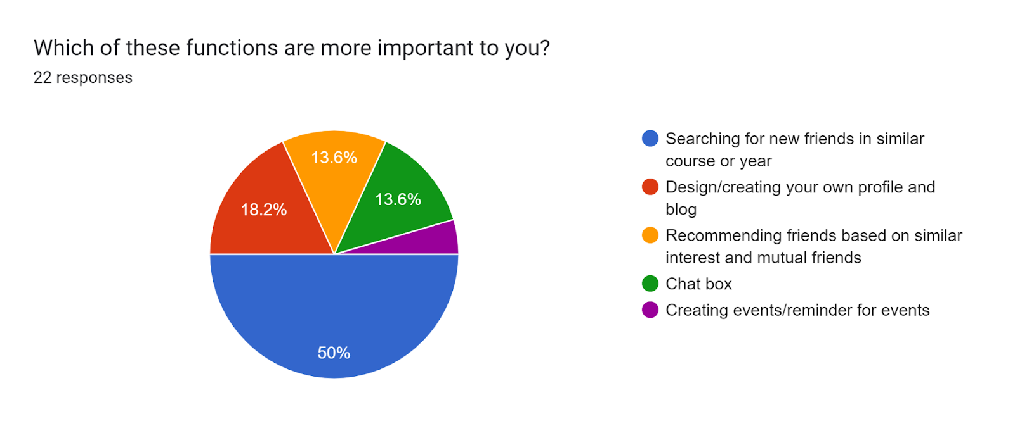

**Analysis:** Exactly half of the students have chosen finding new friends in the same course or year as the most important function in this proposed system. While almost a quarter of the students wanted to create and design their own profile. It can be seen that the needs of these students are gravitating towards the function of social media.

Question 3: What other functions would you like? (short answer)

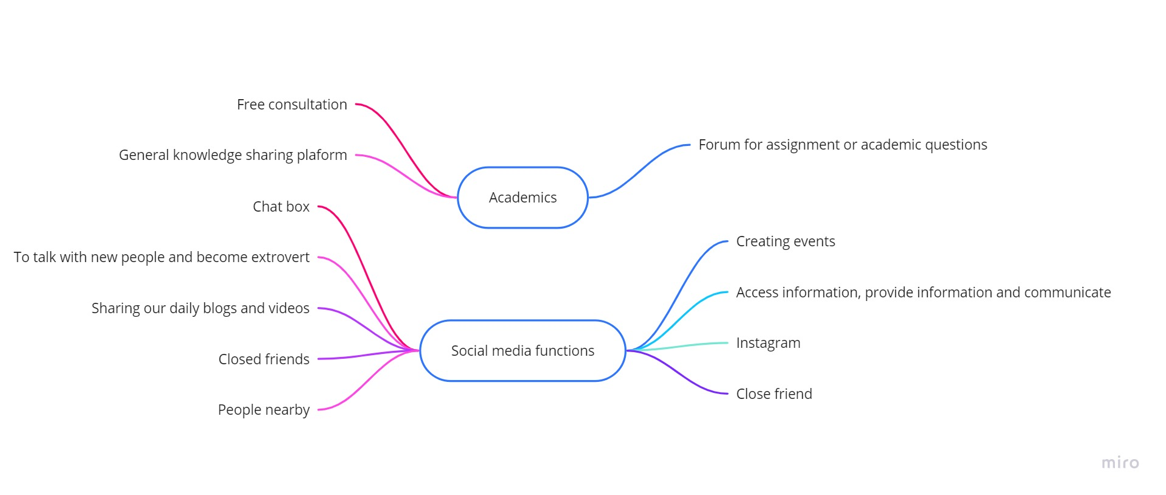

**Analysis:** The shorts answer from the polls can be further summarized as above. It seems that the majority of the students would like the system to have the functions of a social media**.** Some students however would prefer the system to help them in their academics.

Question 4:

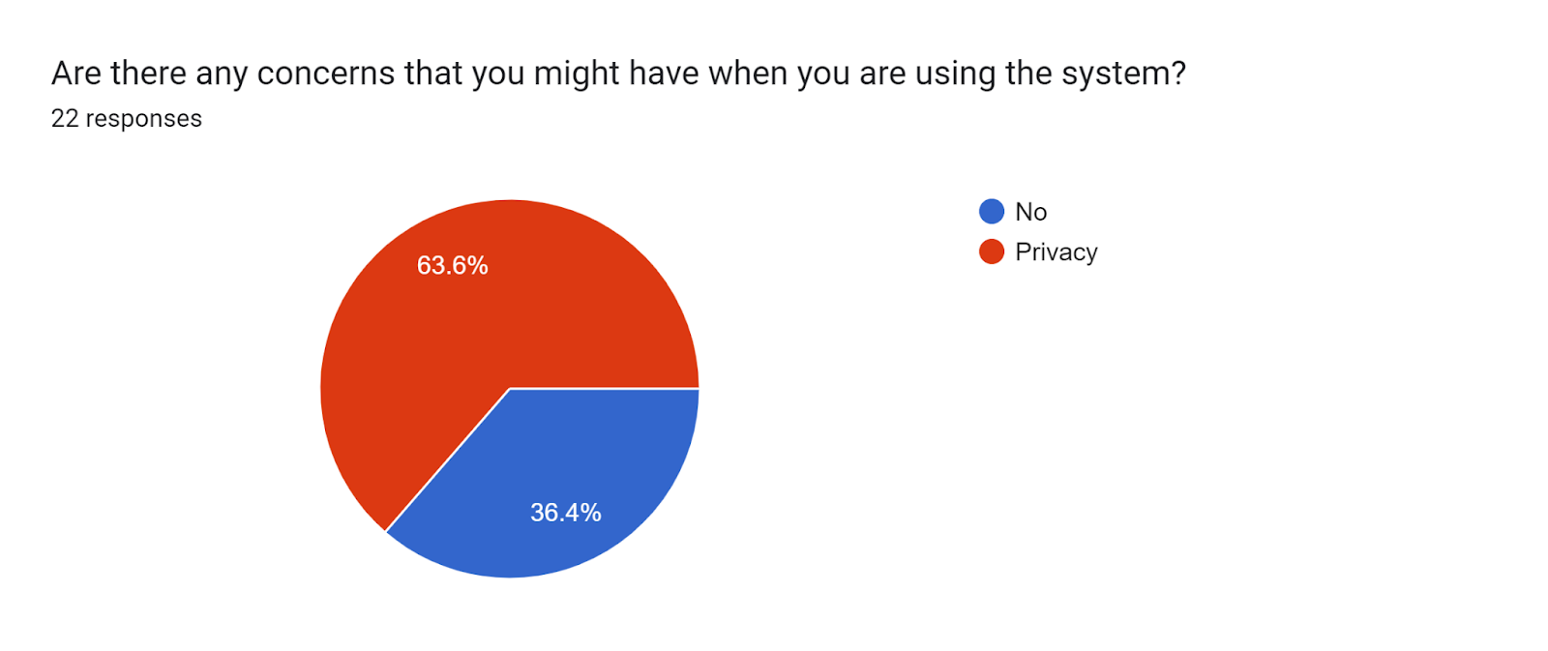

**Analysis:** The polls have shown a  majority of the students are concerned about their privacy. It would be optimal for the system to provide the students with the option to disclose or conceal  their information and postings to the public.

Question 5:

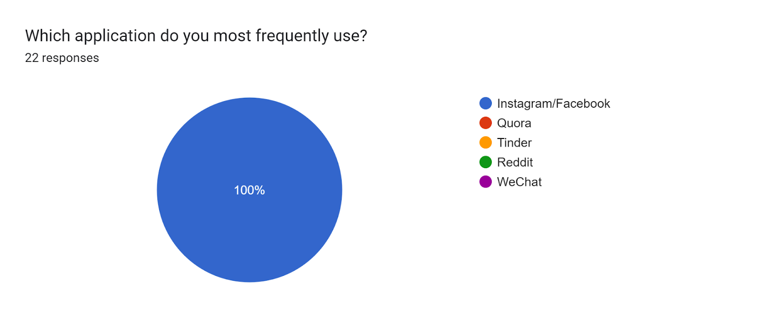

**Analysis:** It can be seen thatall of the students have used Facebook or Instagram the most frequently. The distinctive quality of Instagram and Facebook as compared to other applications is that they allow the users to make new friends and also provide a space for them to publish a snippet of their lives.

Question 6:

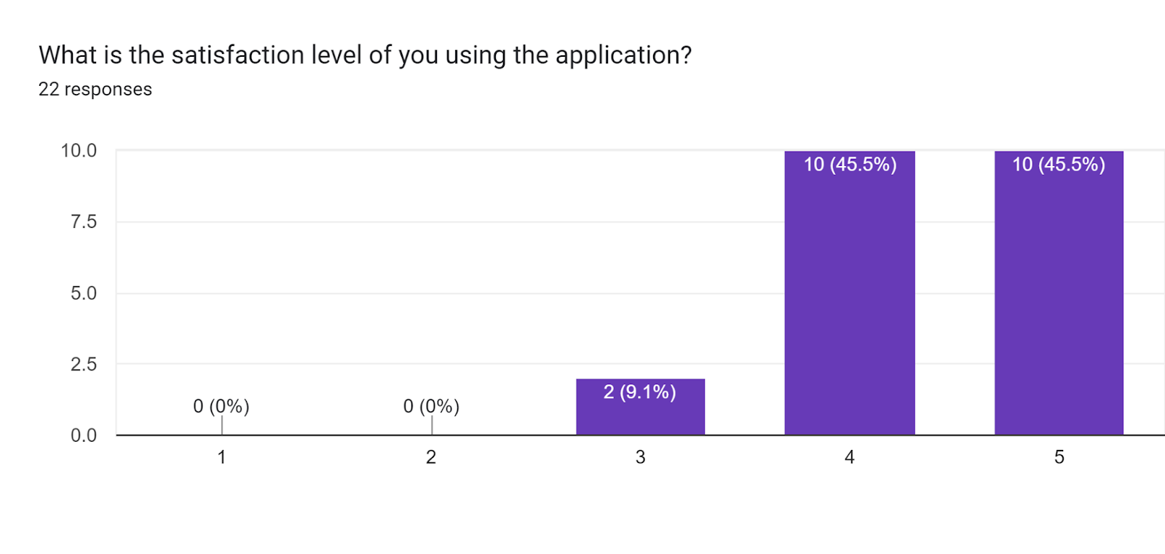

**Analysis**: It seems that a majority of the students are satisfied with the services provided by Facebook and Instagram. The extraordinary features of these applications should be cherry-picked and adopt into the system.

Question 7: What do you like about the application? (short answer)

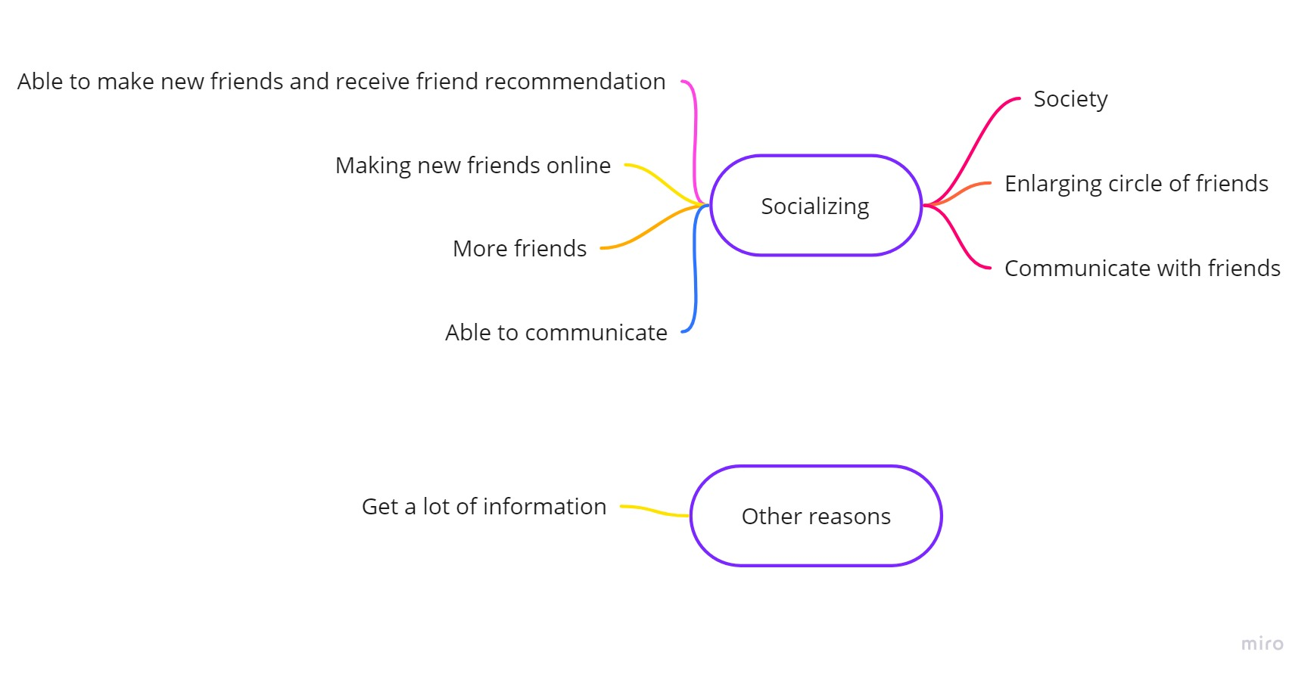

**Analysis**: After further summarizing the data, it can be seen that an overwhelming majority of students have chosen socializing as their main aspect that they liked about Facebook and Instagram.

Question 8: What areas/functions do you think the application above can improve on?

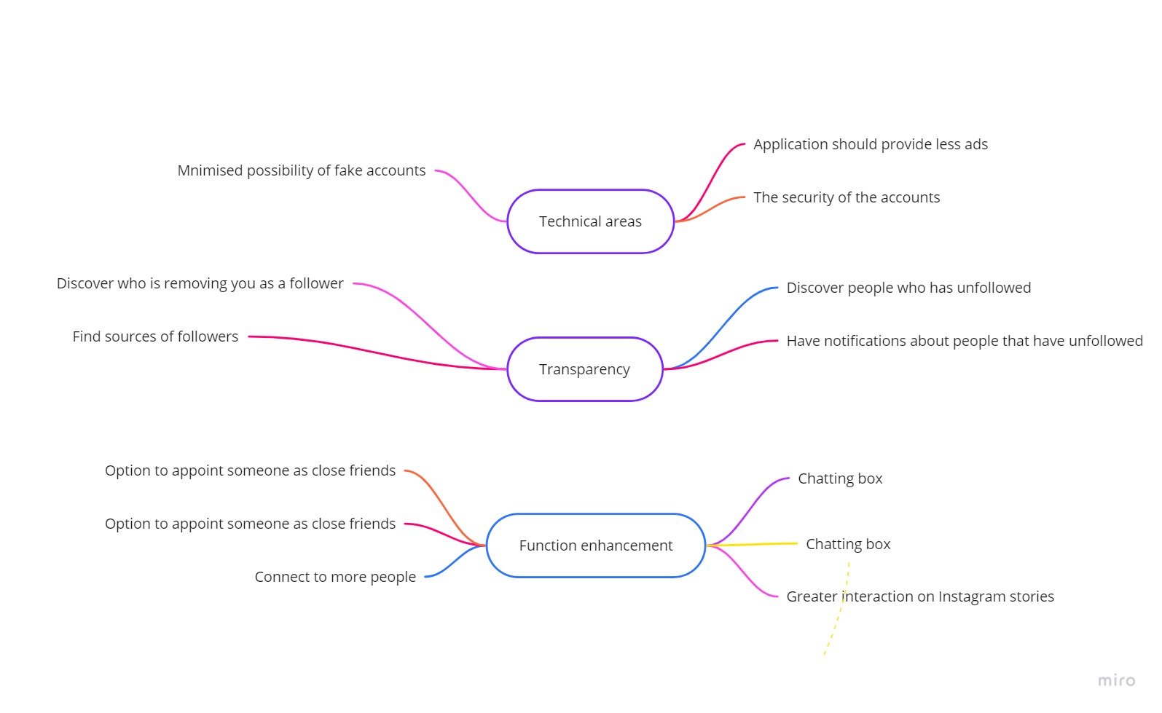

**Analysis**: According to the polls, the answers can be further summarized into three main areas. The majority of the students would like these applications to improve on their existing functions such as the chat box and the ability to appoint someone as close friends. A notable amount of students have also wished that these applications would provide more transparency in clueing in the users when they have been unfollowed or removed as followers. There are some students who think that there is space for improvement for these applications in the technical areas. Chiefly among them are the security of the accounts as well as the proliferation of the advertisement.

Question 9:

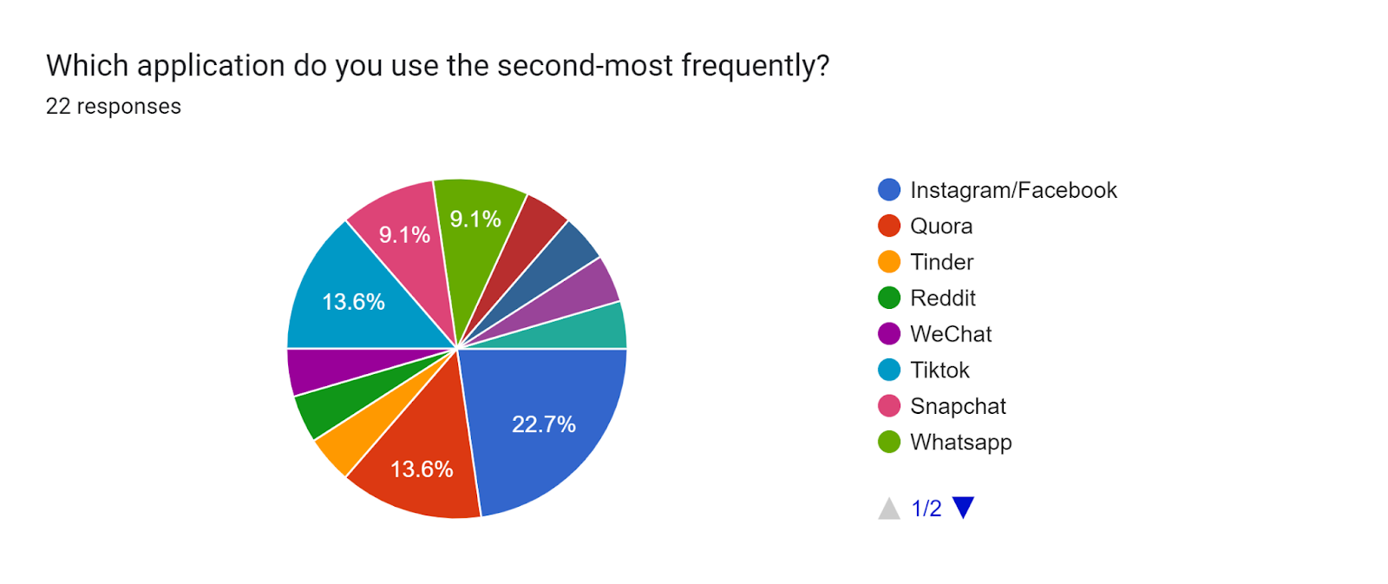

**Analysis**: Since all of the participants have chosen Facebook or Instagram as their most frequently used app, there is some overlapping issues in this pie chart due to Instagram/Facebook being chosen again. However, it still does not change the fact that the second-most frequently used app is more dispersed and lacks a clear winner.

Question 10:

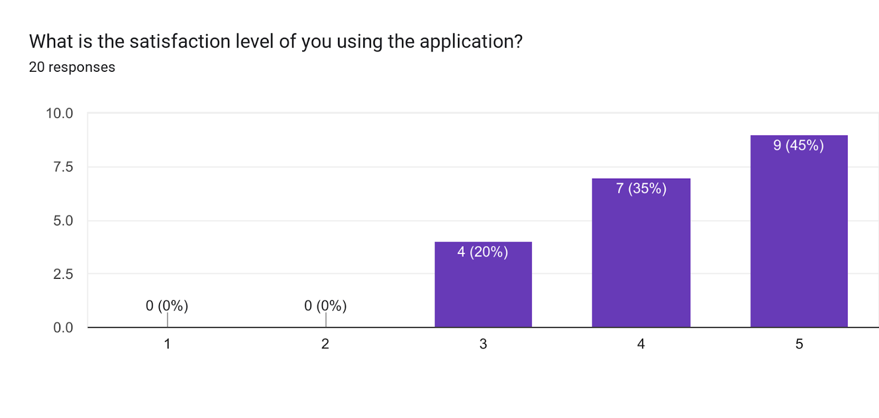

**Analysis**: It seems that the sentiments of the students on their respective app are skewed more towards satisfactory.

Question 11: What do you like about the application? (short answer)

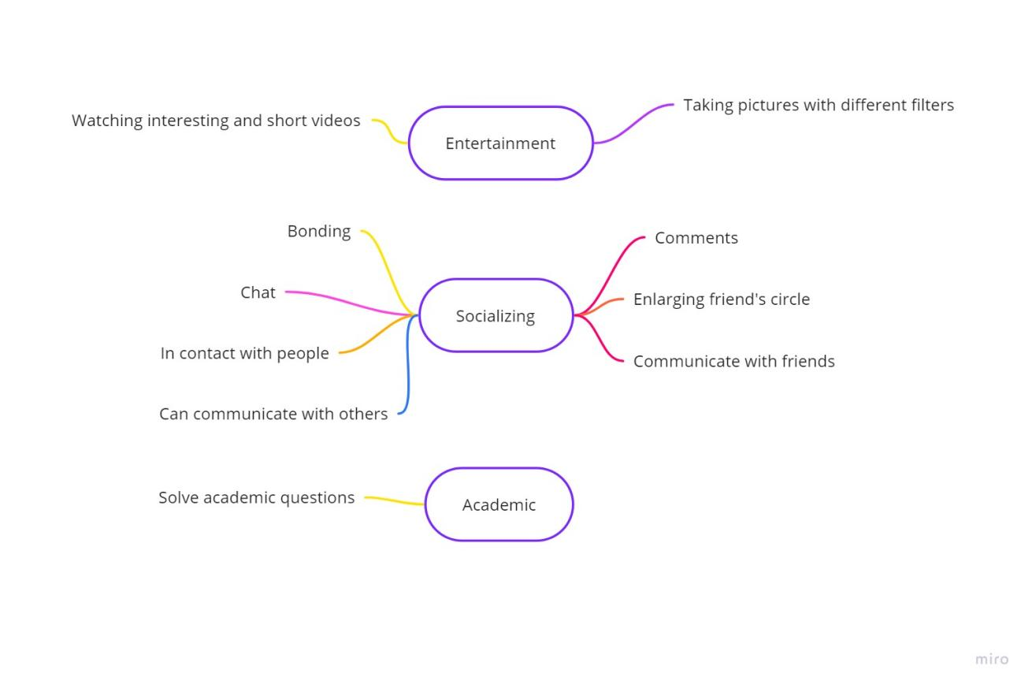

**Analysis**: Despite in the disperse of popularity for the students’ second-most frequently used app, the similarity however lies in where most of the students are using it primarily for its socializing functions. Evidently, there are some other students that would use their second most favourite app for academic and entertainment purposes.

Question 12: What areas/functions do you think the application above can improve on? (short answer)

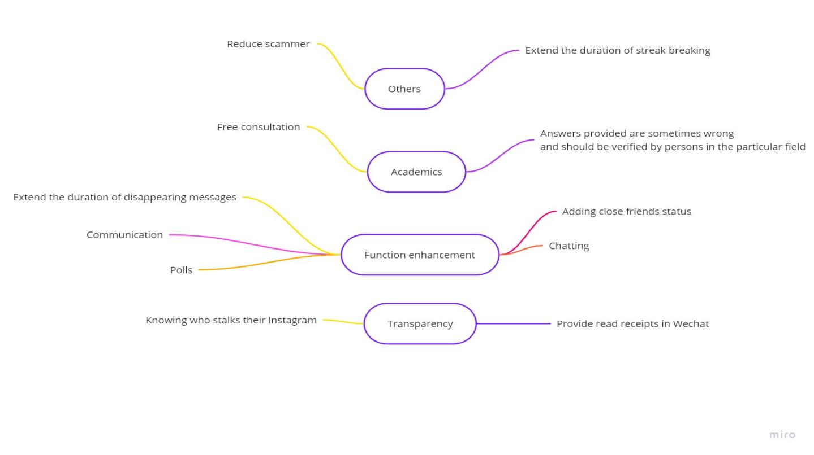

**Analysis**: Despite the majority still thinks that the area of improvement should fall on the enhancement of function, there is a greater spread on opinions in this poll as compared to the previous one. Although transparency still remains as an area of interest, academics and other areas have become a new concern for students when using their second favourite app.

Question 13:

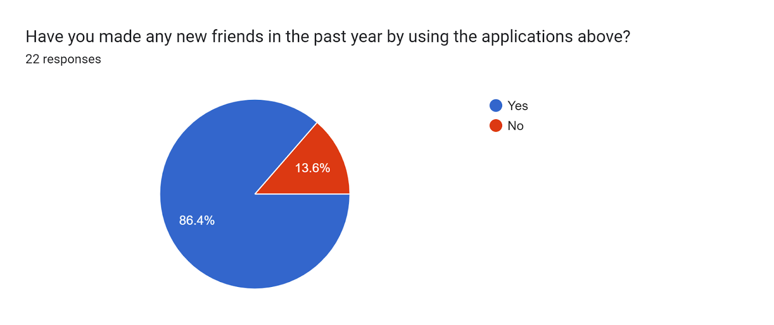

**Analysis**: Most of the students have made at least a new friend by using their favourite app. Nonetheless, it should be noted that are still a few students who have not made any friends at all in the past year.

Question 14:

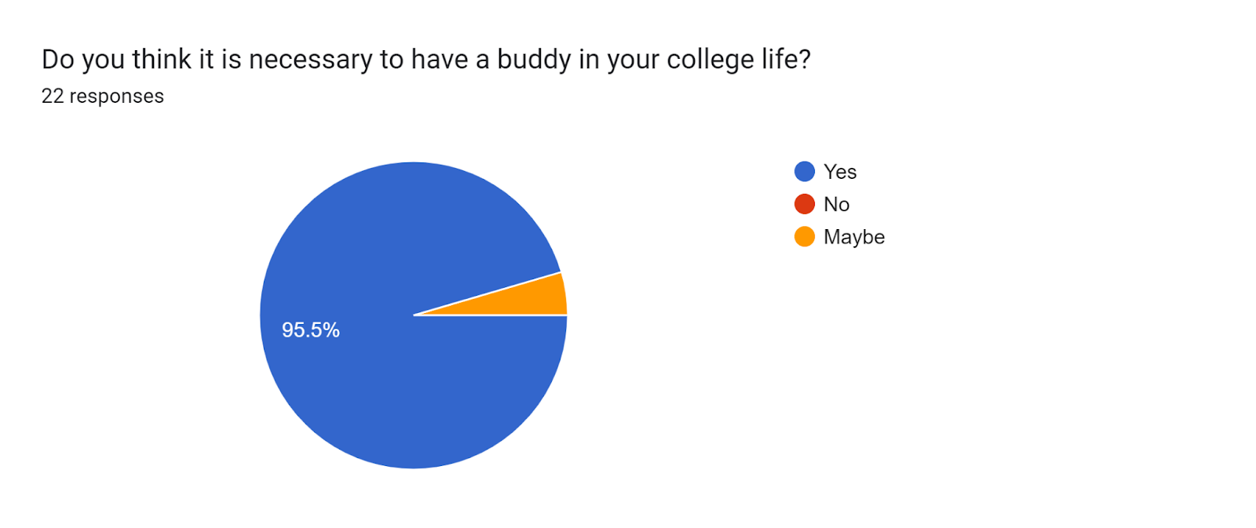

Analysis: Almost all of the students felt that having a buddy is necessary in college life. Hence this statistic establishes the importance

User Story Map

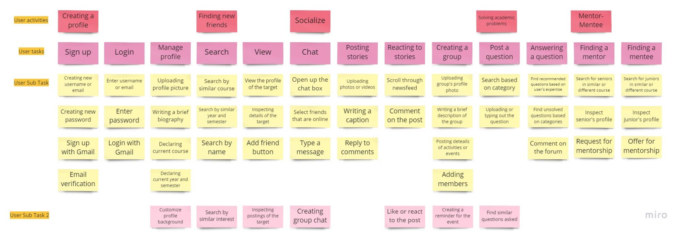

**Appendix**

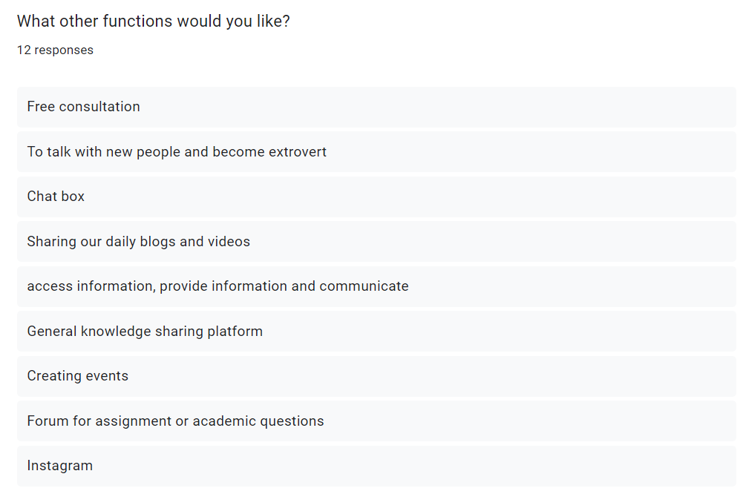

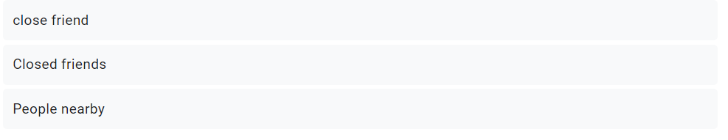

Question 3 questionnaire and answers

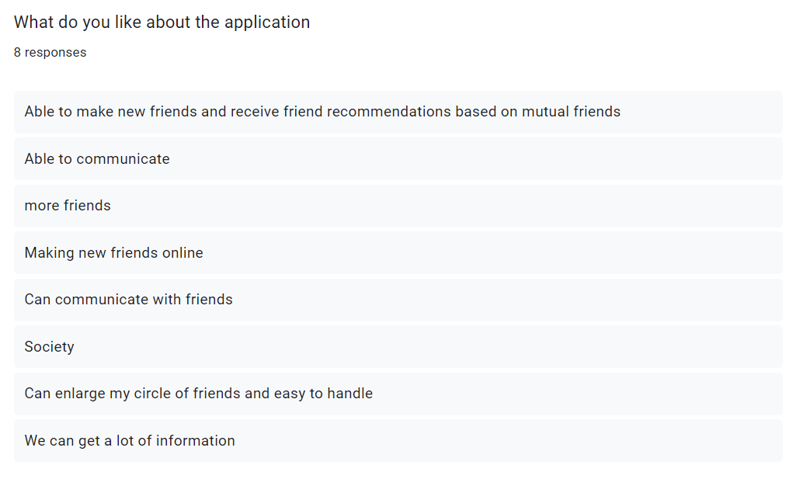

Question 7 questionnaire and answers

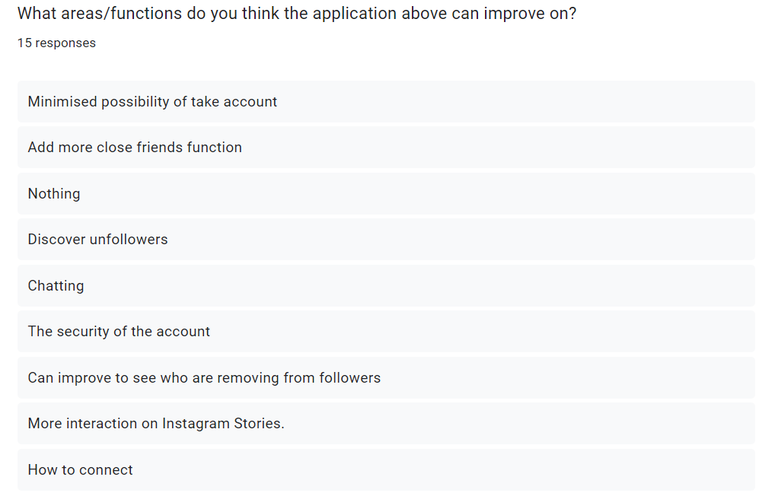

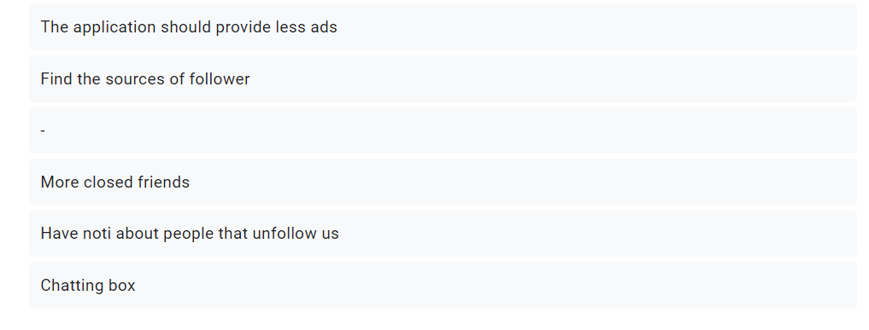

Question 8 questionnaire and answers

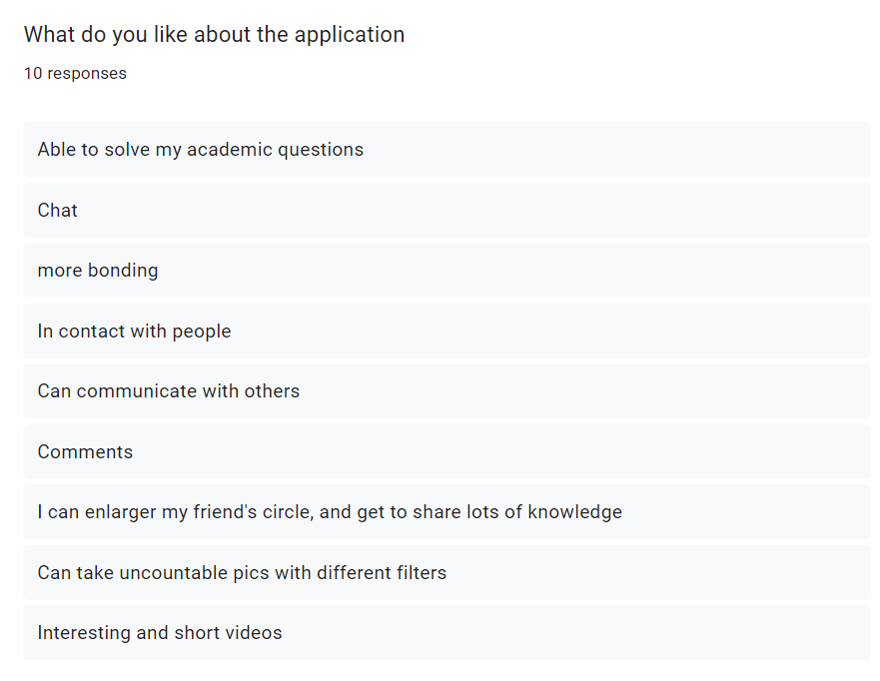

Question 11 questionnaire and answers

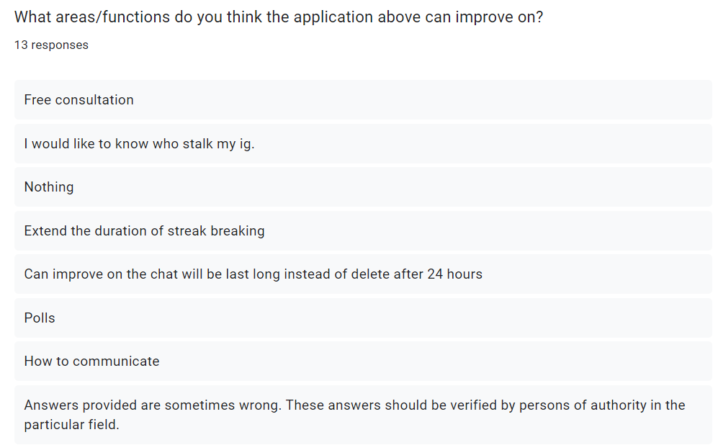

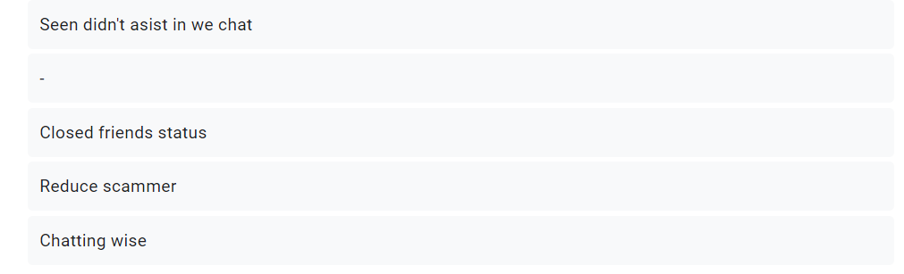

Question 12 questionnaire and answers